

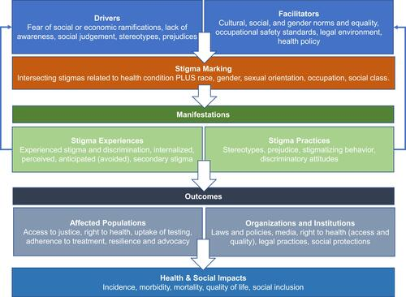

Figure 1 sociodemographic predictors of maternal morbidity by race / ethnicity (Ragsdale et al. )

Ragsdale, A. S., Al-Hammadi, N., Bass, S., & Chavan, N. R. (2024). Racial and Ethnic Disparities Among Pregnancies with Substance Use Disorder: Impact on Perinatal Outcomes. *Journal of Women's Health*.

Weber, A., Miskle, B., Lynch, A., Arndt, S., & Acion, L. (2021). Substance use in pregnancy: identifying stigma and improving care. *Substance Abuse and Rehabilitation*, 105-121.